SEO Introduction – Practical Tasks with Answers
1. Compare Google, Bing, and DuckDuckGo
Search keyword: best budget smartphones 2024
Search Engine | Observation of Top Results
Google | Usually shows popular technology websites, shopping links, featured snippets, and sometimes sponsored results.
Bing | Results may be similar to Google but can show different websites and more visual elements.
DuckDuckGo | Focuses more on privacy and may provide different organic results because it uses different data sources and ranking methods.
Answer / Conclusion:
The top 3 results on all three search engines may not be exactly the same. Google generally provides highly personalized and popular results, Bing may show more visual content, while DuckDuckGo focuses on privacy and does not personalize results based on extensive user tracking.
Screenshot
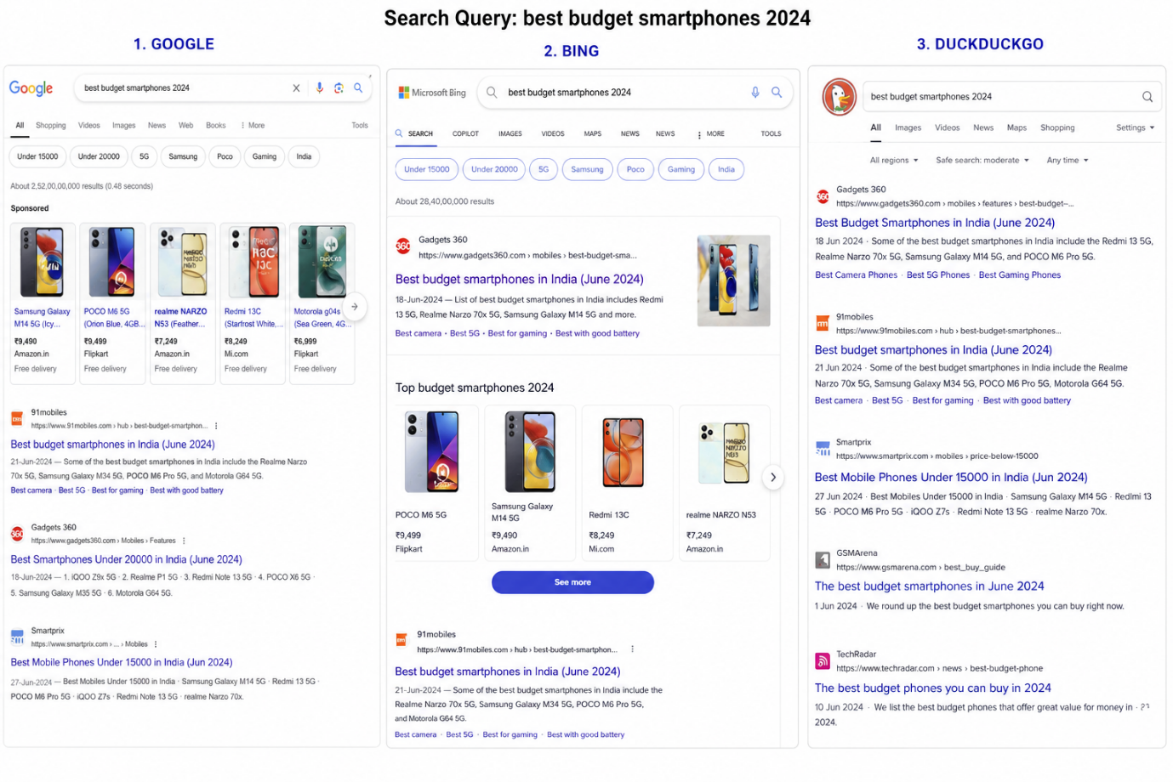

2. Table of 5 Popular Search Engines
Search Engine | One Unique Feature / Reason to Use It
Google | Very large search index and highly relevant search results.
Bing | Strong visual search and integration with Microsoft services.
DuckDuckGo | Focuses on user privacy and does not heavily track search activity.
Yahoo Search | Combines search with news, email, finance, and other portal services.
Brave Search | Privacy-focused search with its own independent search index.

3. Difference Between Organic Results and Paid Results
Organic results are the normal search results that appear because Google considers them relevant and useful for the user's search query. Website owners do not pay Google directly for each click on an organic ranking. Paid results are advertisements where businesses pay to appear for specific keywords. For example, when searching for a product such as “best budget smartphones”, a result marked “Sponsored” or “Ad” is a paid result. A technology website appearing naturally below the advertisements is an organic result.

4. Google Search Process Flowchart
1. Crawling:
Google uses automated programs called Googlebots or crawlers to discover new and updated web pages across the internet.
2. Indexing:
Google analyzes the content of discovered pages and stores information about them in its search index.
3. Ranking:
When a user searches for something, Google evaluates relevant pages and ranks them based on factors such as relevance, content quality, and usefulness.

5. Trending Topic Search – Example
Trending topic selected: New smartphone launch 2026
Result Type | Example | How It Was Identified
Paid Result 1 | Smartphone brand advertisement | Displayed with a Sponsored or Ad label.
Paid Result 2 | Online shopping website advertisement | Appeared as a promoted listing, usually near the top of the results page.
Organic Result 1 | Technology news website reviewing the smartphone | No “Ad” or “Sponsored” label; ranked naturally based on relevance.
Organic Result 2 | Official smartphone product page | Appeared naturally in search results without an advertisement label.
Explanation:
I identified paid results by checking for labels such as “Sponsored” or “Ad.” These results are advertisements paid for by businesses. Organic results did not have these labels and appeared because the search engine considered them relevant to the search query.
